Pool: Taxonomy Profile
Taxonomy Factor | Classification
Name | Pool. Representative title: 8 Ball Pool (Miniclip). Real-money variant: skill-cash pool apps
Candidate Class | Free-to-play competitive skill game with coin-staked matches and paid random boxes (proposed new candidate class; overlaps the paid loot-box and children's reward-token classes)
Primary Audience | Teenagers and young adults. The US App Store listing rates it 13+ and flags loot boxes and contests; the Australian listing shows 16+
Gambling Connection | Moderate / Indirect. Paid chance-based items and coin stakes, but no cash-out route identified for the main game; a 2019 review also reported simulated-gambling side games (Children and Media Australia, 2019)
Addiction / Harm Score | 5/10: Moderate
Risk Score | 5/10: Moderate
Tier Classification | T2: paid random draw, no cash-out (8 Ball Pool). Skill-cash pool apps: T4/T5 boundary
Financial Score | 5/10: Moderate
Monetary Value | Closed-loop virtual currency (coins and cash) bought with real money; official sources identify no conversion to real money
Regulatory Status | 8 Ball Pool: no gambling-regulator action found in the sources reviewed. The US listing is 13+ and the Australian listing 16+, both with loot-box and contest labels (Apple, n.d.-a; Apple, n.d.-b); compliance with Australia's minimum M rating for paid chance-based purchases is unchecked (Australian Classification Board, 2024). Skill-cash pool apps: legality rests on the skill-contest argument; they are prohibited in India since 1 May 2026 (Lexology, 2026; Press Information Bureau, 2026) and the Australian position is unverified.

1. Pool
8 Ball Pool is a free-to-play online pool game from Miniclip. Its core function is competitive pool, but it also runs Surprise Boxes, Scratch and Win scratchers, a Golden Spin, Golden Shot Tickets, and a Pool Pass (Apple, n.d.-b; Miniclip, n.d.). A separate real-money version exists on skill-contest platforms, where players pay an entry fee to win cash prizes (Skillz, n.d.).

2. Description and Connection to Gambling
8 Ball Pool is a free-to-play online pool game from Miniclip. Players can stake in-game currency on the outcome of head-to-head matches (Apple, n.d.-a). Coins and items also come from random "Surprise Boxes" whose contents and probabilities Miniclip publishes, with some top-tier cue pieces at 0.125% (Miniclip, n.d.). The US listing carries App Store labels for loot boxes and frequent contests (Apple, n.d.-a).
Unlike the material of the social-casino apps, there is no indication in the official material reviewed of how the coins can be converted into cash, and match results are based on skill rather than chance. The gambling link is the paid chance-based items (boxes, scratchers, spins), which research considers psychologically similar to gambling (Drummond & Sauer, 2018). There are also skill-cash pool apps; a commercial example is Skillz, which details in general terms how the system works: players pay to enter contests for cash prizes, with the results based on skill. However, the page was not checked for a specific pool title (Skillz, n.d.). According to a Children and Media Australia (2019) review, side games in the app included a spin wheel, a Scratch and Win feature, boxes, and a paid Hi-Lo guessing game, which were described as simulated gambling. The review advised against the app for children aged 15 and under. The review may no longer reflect the current app because it covered only one version, so the functionality of the current version should be verified.

Moderate / Indirect Gambling Connection: The buying behaviour is similar to gambling, while the outcome space of the main game is closed-loop.

3. Age Group and Addiction Risk
Primary age group: Teenagers and young adults. The US listing gives a 13+ rating and the Australian listing 16+ (Apple, n.d.-a; Apple, n.d.-b). Whether the app carries the M rating Australia now requires for paid chance-based purchases should be checked against the Australian rating record (Australian Classification Board, 2024), since a 2025 preprint found many top games wrongly classified (Carter et al., 2025).
Addiction / Harm Score: 5/10: Moderate. Documented mechanics:
- Coin-staked matches. Players stake in-game currency on head-to-head matches (Apple, n.d.-a). The 2019 Children and Media Australia review reported that the starting currency ran out after a few short losses, after which players had to watch advertisements or buy more (Children and Media Australia, 2019).
- Paid random draws. Surprise Boxes, scratchers and spins with published low-probability top prizes, a variable-reward structure of the kind examined in loot-box research (Miniclip, n.d.; Apple, n.d.-b).
- Simulated-gambling side games (reported in 2019). The 2019 review described a spin wheel, Scratch and Win, boxes and a Hi-Lo guessing game, some requiring real money (Children and Media Australia, 2019); whether they remain in the current version was not confirmed.
- Low, frequent price points. The US listing shows purchases from US$0.99 (Apple, n.d.-a).
Across 13 publications, the mean association between loot-box spending and problem gambling was r = .27 (Spicer et al., 2022), and a review of 64 outputs found reliable evidence linking loot boxes to problem gambling and gaming disorder, with only some evidence of financial harm (Greer et al., 2022). The score is lower than the social-casino apps because purchased in-game currency is not wagered on a casino game, and no cash-out route was discovered. This is a taxonomy assessment, not a clinical diagnosis.

4. Risk or Danger
Risk Level: Moderate: 5/10.
- Chance-based purchases in a product open to teenagers. The 13+ US rating and loot-box label place paid random draws in front of young players.
- Unofficial coin market and scams. Miniclip says the third-party coin sellers are not affiliated and cautions that users could face having their accounts banned or hacked, as well as losing payments (Miniclip Help and Support, n.d.). Resale value should be considered before finalising T2, because confirmed resale for real money would indicate T3.
- Real-money pool variants alter risk exposure. Entry fees result in direct losses, and legality hinges on the skill-contest argument, which differs between jurisdictions. Cash competitions are not available in all areas, according to a commercial vendor, Skillz (Skillz, n.d.). This vendor statement has not been independently confirmed. The International Masters of Gaming Law (IMGL, 2026) reports that India’s 2025 Act does not distinguish between skill and chance in money games. The Australian position has not yet been established in this assessment and needs to be reviewed against the Interactive Gambling Act 2001 (Cth).

5. Tier Classification
Tier: T2: Paid Random Draw, No Cash-out (8 Ball Pool).
Classification path (8 Ball Pool):
8 Ball Pool → coins and cash bought or earned → coin-staked matches, Surprise Boxes, scratchers → virtual items and coins → no official cash-out route → T2
Path of Classification (skill-cash pool):
Skill contest pool application, cash entry fee, head-to-head/bracket competition, cash prize, and T4/T5 border.
Note for the taxonomy: 8 Ball Pool contrasts with the social-casino apps. Both spend purchased currency, but only the casino-style apps wager it on a chance game, which supports separating "paid random draw" from "stake on chance" as facets within T2.

6. Harm: Financial Harm and Psychological Harm
Financial Score: 5/10: Moderate
Financial harm. Loss is incremental, with small purchases accumulating over time. A review found some evidence linking loot-box purchasing to financial harm (Greer et al., 2022). Nothing in the sources reviewed puts a figure on pool-specific spending, so the financial score is an estimate.
Psychological harm. Time displacement, frustration and compulsive re-engagement are plausible pathways, but no peer-reviewed pool-specific research was found; the 2019 review is a consumer-advocacy assessment, not a study of harm outcomes (Children and Media Australia, 2019). The loot-box and problem-gambling association is the closest evidence (Spicer et al., 2022), and Langham et al. (2016) place emotional and psychological harm within their seven-category taxonomy of gambling-related harm.

7. Monetary Value
Monetary Value: Closed-loop virtual currency (no cash-out identified); real cash in and out for skill-cash variants
Cash-out pathways:
- 8 Ball Pool: none identified in official sources. Coins, cash and cues are usable only inside the game.
- Unofficial market: third-party coin sellers exist (Miniclip Help and Support, n.d.). Whether coins or accounts can be resold by players for money is unverified.
- Skill-cash pool: entry fee → prize pool → cash prize paid to winners (Skillz, n.d., vendor description).

8. Evidence as Images
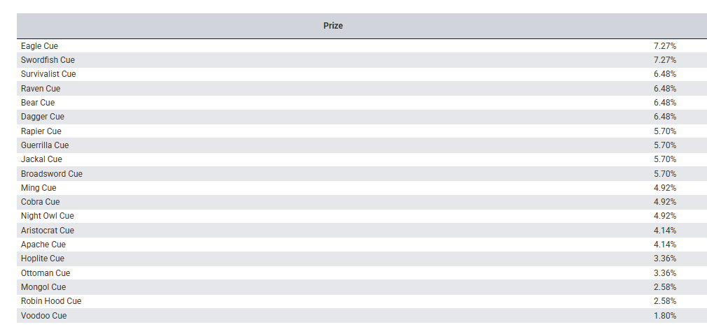 | 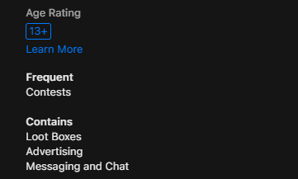
Figure 5: Miniclip page listing Surprise Box prize contents (probability column cut off in this capture) | Figure 6: 8 Ball Pool US App Store information panel (app name not shown): 13+ rating, frequent contests and loot-box labels
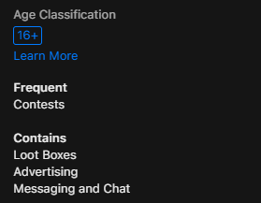 | 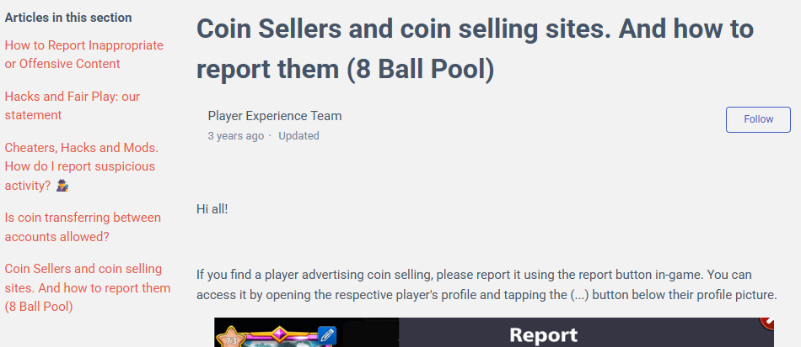
Figure 7: 8 Ball Pool Australian App Store information panel (app name not shown): 16+ classification, frequent contests and loot-box labels | Figure 8: Miniclip support page on coin sellers and coin-selling sites

9. References
Apple. (n.d.-a). 8 Ball Pool [App Store listing, Miniclip SA]. Retrieved 21 September 2026, from https://apps.apple.com/app/543186831
Apple. (n.d.-b). 8 Ball Pool™ – 3D Online Pool [App Store listing, Australia]. Retrieved 21 September 2026, from https://apps.apple.com/au/app/8-ball-pool-3d-online-pool/id543186831
Australian Classification Board. (2024). New classifications for gambling-like content in video games. https://www.classification.gov.au/about-us/media-and-news/news/new-classifications-for-gambling-content-video-games
Carter, M., Zhangshao, T., Hardwick, T., Egliston, B., & Xiao, L. Y. (2025). Investigating mobile games' compliance with Australia's 2024 mandatory minimum age classifications scheme for gambling-like mechanics [Preprint]. SSRN. https://doi.org/10.2139/ssrn.5543999
Children and Media Australia. (2019, February 4). App review of 8 Ball Pool. https://childrenandmedia.org.au/app-reviews/apps/8-ball-pool1
Drummond, A., & Sauer, J. D. (2018). Video game loot boxes are psychologically akin to gambling. Nature Human Behaviour, 2(8), 530–532. https://doi.org/10.1038/s41562-018-0360-7
Greer, N., Murray Boyle, C., & Jenkinson, R. (2022). Harms associated with loot boxes, simulated gambling and other in-game purchases in video games. Australian Institute of Family Studies. https://aifs.gov.au/research-programs/australian-gambling-research-centre/loot-boxes-simulated-gambling-video-games-harms
Interactive Gambling Act 2001 (Cth). https://www.legislation.gov.au/C2004A00851
International Masters of Gaming Law. (2026). What India's new regulations mean for online gaming. IMGL Magazine, 3(1). https://www.imgl.org/publications/imgl-magazine-volume-3-no-1/what-indias-new-regulations-mean-for-online-gaming/
Langham, E., Thorne, H., Browne, M., Donaldson, P., Rose, J., & Rockloff, M. (2016). Understanding gambling related harm: A proposed definition, conceptual framework, and taxonomy of harms. BMC Public Health, 16, Article 80. https://doi.org/10.1186/s12889-016-2747-0
Lexology. (2026, May 6). Setting the rules of the game: India's online gaming law comes into force. https://www.lexology.com/library/detail.aspx?g=29103459-cefe-4528-a762-dbd53ce6979e
Miniclip Help and Support. (n.d.). Coin sellers and coin selling sites, and how to report them (8 Ball Pool). https://support.miniclip.com/hc/en-us/articles/218963947-8-Ball-Pool-coin-sellers
Miniclip. (n.d.). 8 Ball Pool [Surprise Box contents and probabilities]. Retrieved 21 September 2026, from https://www.miniclip.com/minigames/8ballpool
Press Information Bureau. (2026). Promotion and Regulation of Online Gaming Rules, 2026 [Press release]. https://www.pib.gov.in/PressReleasePage.aspx?PRID=2256973&reg=3&lang=2
Skillz. (n.d.). The legality of skill gaming [Vendor documentation]. https://docs.skillz.com/docs/legal-skillz/
Spicer, S. G., Nicklin, L. L., Uther, M., Lloyd, J., Lloyd, H., & Close, J. (2022). Loot boxes, problem gambling and problem video gaming: A systematic review and meta-synthesis. New Media & Society, 24(4), 1001–1022. https://doi.org/10.1177/14614448211027175

